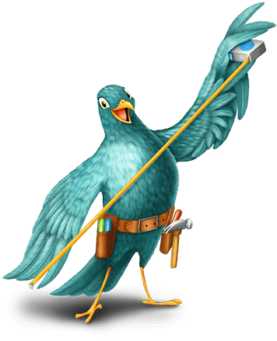
Maker Fun Factory VBS 2017
Westminster Presbyterian Church
3 – 7 July

Liability Waiver

Release of Liability
I understand that there are risks associated with all indoor and outdoor VBS activities, I agree not to hold Westminster Presbyterian Church, its staff, members or VBS volunteers liable for any claims of damages or injury to my child or to my child’s property that may occur through the normal course of VBS. I understand the VBS Leaders will make every reasonable attempt to provide a safe and caring environment for my child.

Medical Custody
I authorize the VBS Leadership of Westminster Presbyterian Church to seek and authorize medical attention in the event that my child will need emergency medical care, and that I will assume all cost related to transport and/or care. I understand that all effort will be made to contact the parents/guardian, however, if contact cannot be made, assistance will be authorized by the church’s VBS Leaders.

Publicity
I hereby authorize Westminster Presbyterian Church to take pictures of my child during VBS activities and to use anonymous images of my child for ministry purposes (such as the church newsletter, website, and slide show during the Sunday Worship service).

By signing the form below –
- I indicate that I have read all the information on this form.
- I grant consent to all permissions and agree to all waivers on this form.

Name of Parent/Guardian (please print) _____________________________________________

Signature________________________________ Date _________________________________

Child’s Name ___________________________________________________________________

Address _______________________________________________________________________

City ____________________________________ Province ______________________________

Postal Code _____________________________ Email _________________________________

Witness ________________________________ ______________________________________
Signature Print Name

