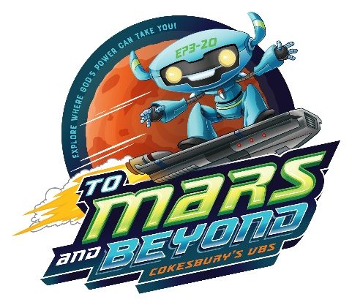

One small step for your kids

One giant leap for God's kingdom!

Join us as we blast off
To Mars and Beyond!
Kids will become Voyagers on a journey through space, exploring where God's power can take them. Our daily special missions will begin at our Mars outpost and lift off to explore distant planets. Along the way, kids will learn how God walked with heroes of the Bible and that God is always with them too.

Serving Ages 4 through 6th grade
Where: Westminster Presbyterian Church
When: July 2, 2019 to July 5, 2019
8:45am-12 noon
Out of this World Fun, Friendships, Science,
Music, Crafts and more!
Registration opens April 22, 2019 at: http://bit.ly/WPCVBS2019
We invite you to get involved with this fantastic ministry. We are looking for adult and youth volunteers who would be willing to help lead this mission.
If you are interested you can sign up to volunteer at the above listed web address, or if you have any questions,
please contact Judy Bosch or Kathy Neuland at
Westminster Presbyterian Church at 403-241-1443.

